Analyse document  
Thomas Pouw

Project Wishlist

# Expected outcomes

The Idea what I had was to make a website where your friends (That you added to your account) can look at your Wishlist and chose one to buy for you. And to prevent others choosing the same product it will only show the friends who has chosen that product of the Wishlist.

The friends can also make an anonymous recommendation request to the owner of the Wishlist.  
Where the owner of the Wishlist can answer with 3 options: “Yes”, “Maybe” or “No”.  
The request and the answer will appear on the same page under different sections.

If you want to share it with your friends, then you can click the generate link button so that others can excess your Wishlist. And when the recipient clicks on the link for the first time it will choose a nickname for them. Because otherwise it would be hard to communicate.  
  
When looking at somebody’s lists. You can post a message under it. This will be done anonymous, or you have to say that you want it to say your account, it’s the user’s choice.

# Requirement

## Functional requirements

|  |  |  |  |
| --- | --- | --- | --- |
| **Admin** | | | |
| FR-01 | The admin should be able to see any profile on the website. | | |
| FR-02 | The admin shouldn’t be able to assign a product to himself if he isn’t a friend of that user. | | |
| FR-03 | The admin should be able to delete an item of the website without causing problems with the effected Wishlist’s and the already assigned people. | | |
| FR-04 | The admin should be able to see all the products that the community has added to the website. | | |
| FR-05 | The admin should be able to create and delete categories and age ratings of the websites. | | |
| FR-06 | The admin has the power to prevent people from adding or editing a new product if that person causes to much trouble. | | |
| FR-07 | The admin can see which categories are the most popular and which are the least popular. | | |
| FR-08 | The admin should see the problematic in order of how many times they got posted. | | |
|  | A | If two multiple products share the same amount of reports then first order on the date of first report and latest report date. | |
| FR-09 | An admin should be able to promote a user to Admin/Moderator. | | |
| FR-10 | The admin account should also double as a user account by pressing a button. | | |
| **General** | | | |
| FR-11 | The User should be able to register their account | | |
| FR-12 | The User must be able to log in | | |
| FR-13 | Everybody has the power to add a new product to the system. | | |
| FR-14 | Everybody has the power to edit a new product to the system. | | |
| FR-15 | Everybody should be able to give and remove categories and age ratings from products. | | |
|  | A | Certain categories require Age ratings. So, you can’t leave it blank in that case. | |
| **System** | | | |
| FR-16 | If the system sees that newly added product has the same name and publisher as an already existing product. It will refuse to add that product to the system and will link the user to that products page instead. | | |
| **User** | | | |
| FR-17 | The user can put a warning if a product is risky. (So, if its counted problematic) | | |
| FR-18 | The user should be able to add and remove products from their Wishlist. | | |
| FR-19 | The user should be able to link their Wishlist to other people. | | |
| FR-20 | If the user isn’t logged in or hasn’t allowed 18+ products to appear anywhere. They will not appear in Search. | | |
| FR-21 | The user will get a parental warning if the birthdate they inserted is less then the recommended age rating. | | |
|  | A | | The user will also get a parental warning if the product has that enabled. |

## Non-Functional Requirements

|  |  |
| --- | --- |
|  | |
| NFR-1 | The product should use the CI/CD |
| NFR-2 | The Product should have version control |
| NFR-3 | The loading of a page shouldn’t take more than 1 second. (When plugged in an ethernet cable) |
| NFR-4 | The Product should use a Distributed system. |
| NFR-5 | The product should be easy to use for the User. |
| NFR-6 | The Database shouldn’t take more than 0.5 seconds to give the required data. |

# Wireframe

## Wishlist

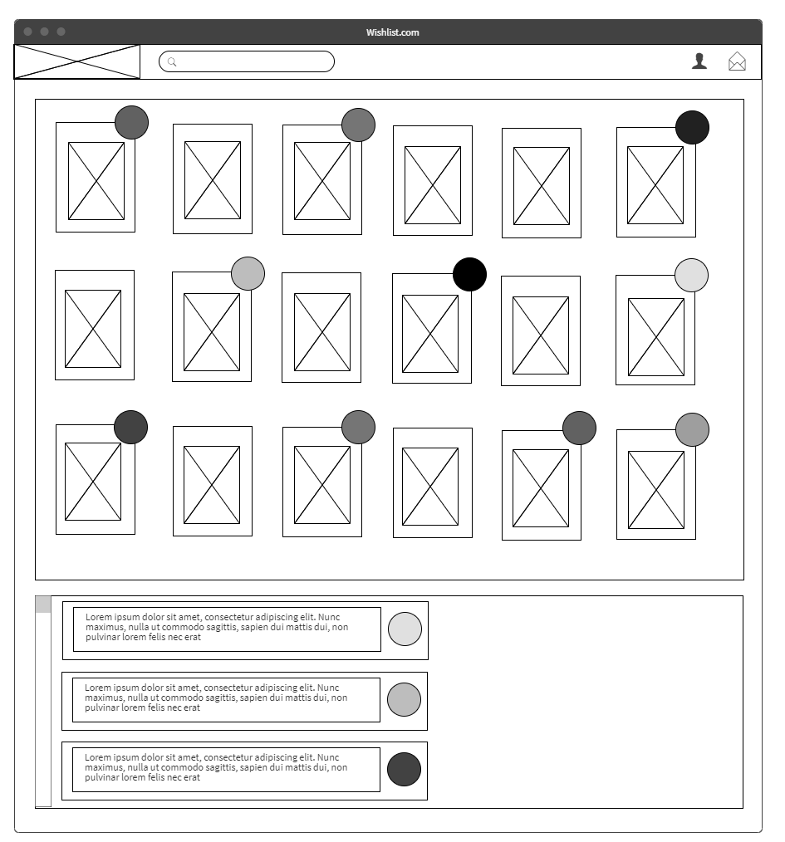

## Search

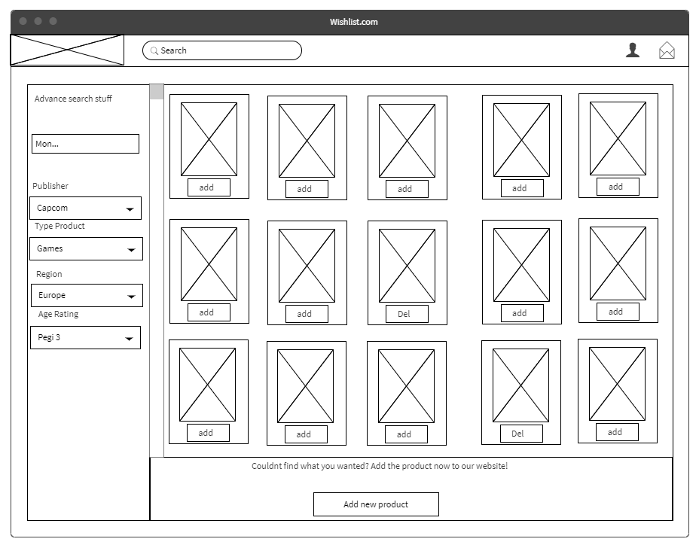

## Add and Edit

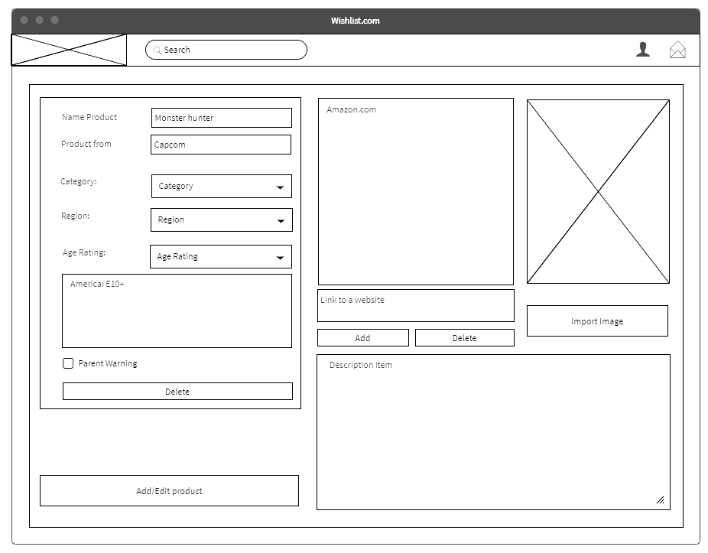

## Admin page

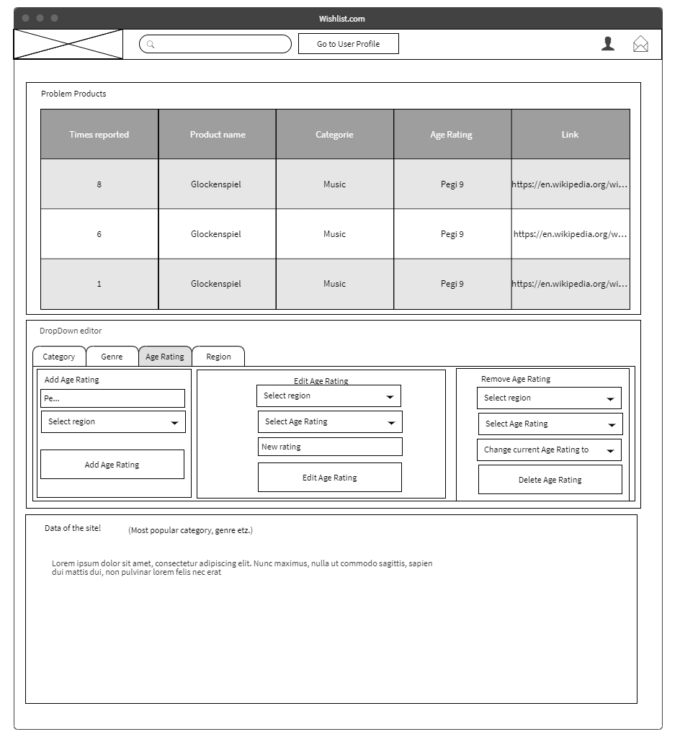

## User Page

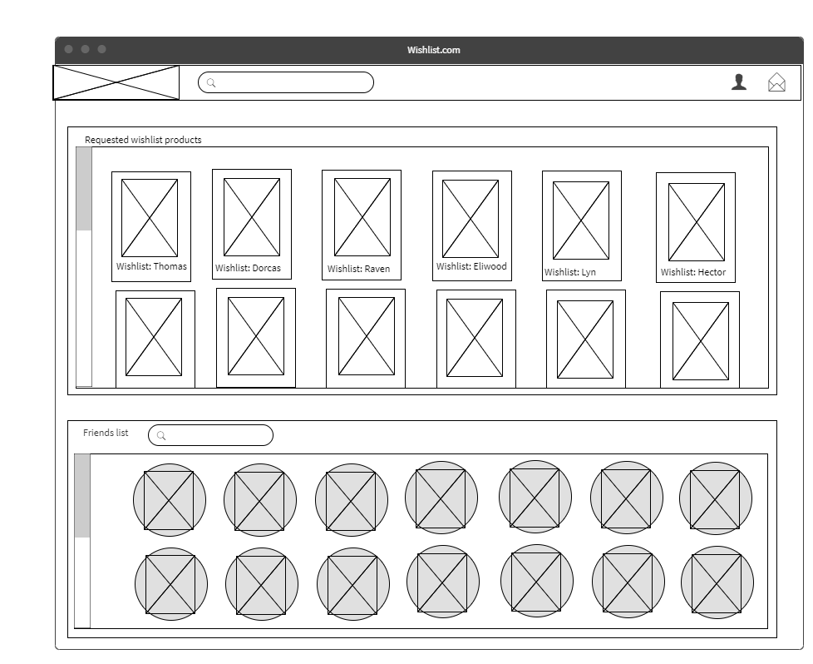

# User Story

## -Admin

As an Admin I want to see all the products I want to see all and moderate the accounts as easy as possible as possible. So, from the admin page I just have to click one button to find the accounts search for the user.

I also want to see what kinds of products are the most popular by type, genre, and age group.  
  
I also want to have my own normal account inside of the admin account. And it will warn me if I go in and out of the Admin Account. So, I won’t be confused what power I have at that time.

Also, a thing that I can do is delete, edit, and add products, types, age ratings and genres.  
People can send us, the admins a notification of a problematic product by pressing a button.   
That product will be put on a list. The more people pressed the button for that product how higher it is on the list. Products will only be removed if it is considered problematic for the site.

## -General User

As a general User I want to see my Wishlist, who my friends are and what I have requested to buy for them.  
So I want to easily add my friends to my account. Just by sending their account a friend request.

If I want to add a product to my Wishlist it’s as simple as looking up the product in the search page and adding it to my Wishlist. If the product didn’t exist yet I will just press the “Add new product” button and it will send me to the correct page there I can just add all the necessary information in the editor, and it will ask me if I want to add it to my Wishlist when I say it is done.

If I see that something on the product page isn’t correct, I can edit it by pressing the “Edit Product” button. And I will be sent to a similar looking page as the add product page and I can edit the product page just like that.

For deleting you either go to your Wishlist, find the item and hover over it for it to say “Remove from Wishlist” or you go to the search bar and remove it from there.

If a friend sends a link to join their Wishlist party I will see all the people who are invited and who already selected their request. If I hover over one of the products in that list, I can request it. If for some reason I don’t want to buy that product anymore. You can just hover over it again and it will now say “Cancel request”.